IIS Mover Admin Guide

Chad Weirick

Table of Contents

Pre-Installation Requirements 2

Installation 2

Updates 2

|  |
| --- |
| Pre-Installation Requirements |

Proper use of IIS Mover requires access to IIS Application Pools (Hereafter referred to simply as app pools). The check for app pools is conducted at launch 100% of the time regardless of the selected tasks. As such, any user of IIS Mover will need access to the following folder: %windir%\System32\inetsrv

Note: Read access is a minimum requirement, however access to read/write is needed if app pool manipulation is a desired task.

|  |
| --- |
| Installation |

IIS Mover is a portable application, meaning that it can be installed anywhere. Alternatively, you can load the solution in Visual Studio and build out an installer. This is an additional step and should only be used in very specific use cases as determined by a network administrator.

|  |
| --- |
| General Use |

A user’s guide is included in the documentation; however a general overview of IIS Mover and its intended use can be outlined in this flowchart:

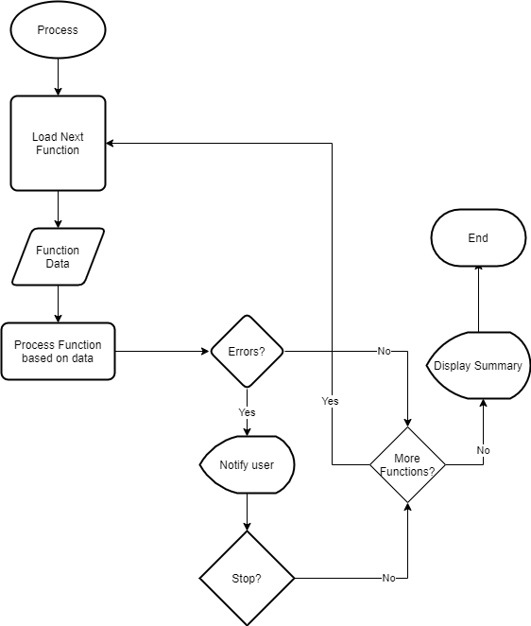

|  |
| --- |
| Updates |

Updates are available at this URL: <https://github.com/chadatgcu/IIS-Mover.git>